Project Design Phase
Solution Architecture
Date | 24 September 2026
Team ID | SWTID-2026-9408
Project Name | Streamlining IT Procurement: Automating Standard Laptop Orders with Flow Designer
Maximum Marks | 4 Marks

Solution Architecture:
Solution architecture bridges the gap between the business problem and the technology solution. For this project, its goals are to:
- Find the best tech solution to solve the existing manual laptop-procurement problem.
- Describe the structure, characteristics and behaviour of the automation to project stakeholders.
- Define the features, development phases, and solution requirements.
- Provide specifications according to which the solution is built, managed, and delivered.

Solution Architecture Diagram
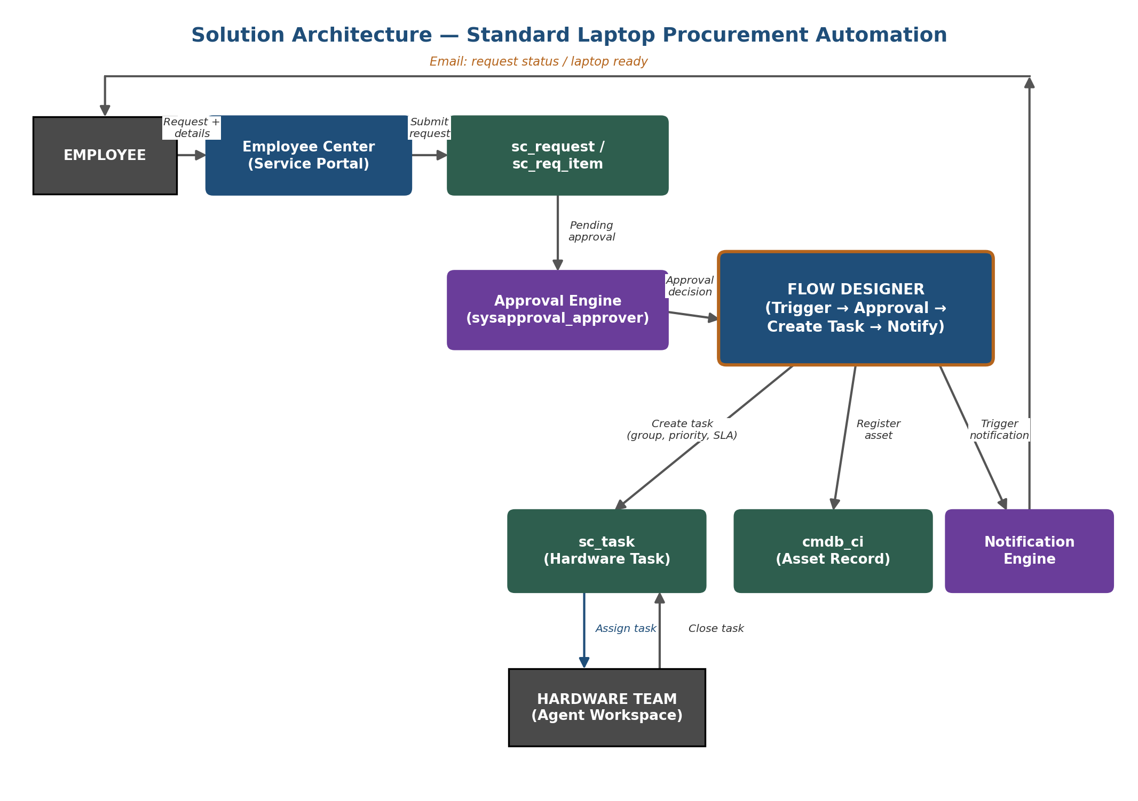
Figure 1: Architecture and data flow of the standard laptop procurement automation, built entirely on native ServiceNow components (Service Portal, Approval Engine, Flow Designer, and platform tables) with no external integration required for Phase-1.

